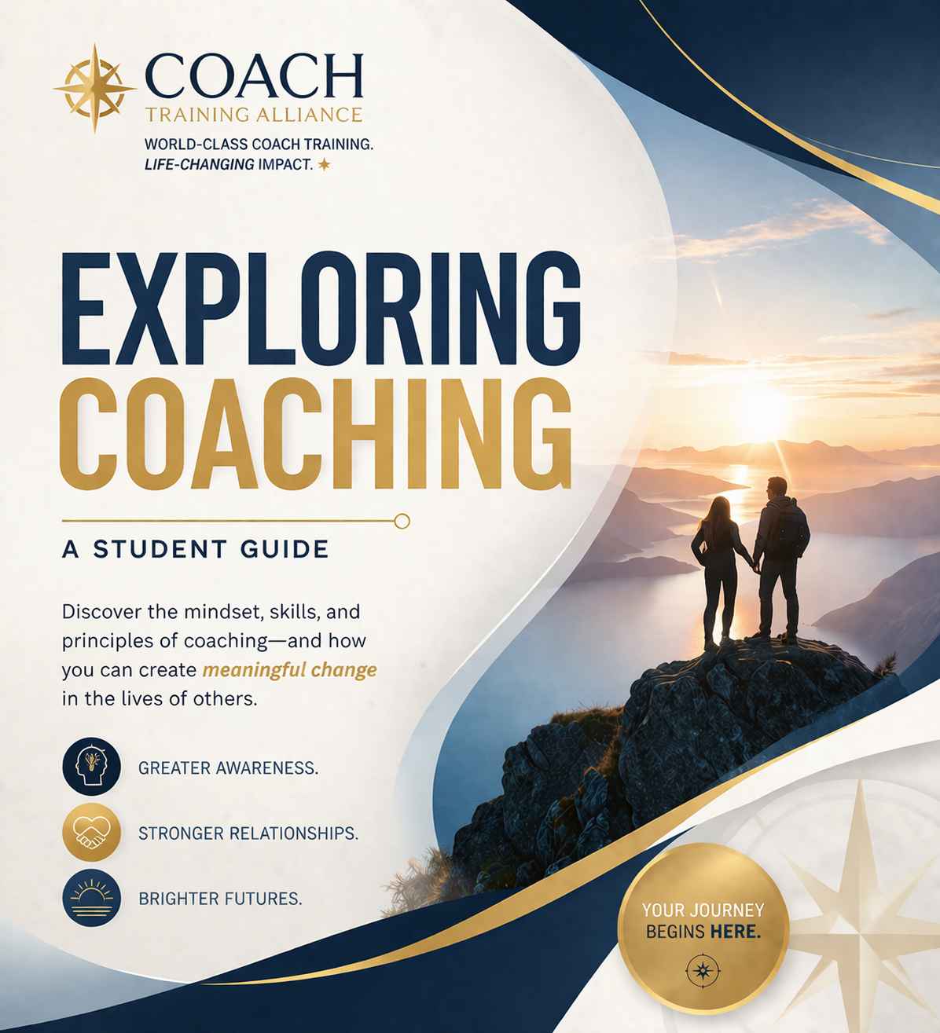

Exploring Coaching

A Guide from Coach Training Alliance

Welcome. We are glad you are here.
If you have found your way to this guide, there is likely something in you that is curious about coaching, or perhaps already senses that this path matters.
At Coach Training Alliance, we believe coaching is more than a skill. It is a way of listening, thinking, and partnering that creates meaningful change.
This guide is designed to help you understand what coaching really is, why it works, and what it requires to do it well.
As Mentor Coaches, we have had the privilege of supporting thousands of students as they develop their voice, their confidence, and their coaching presence. Our intention is that this guide begins that process for you.
Take your time with it. Reflect. Notice what resonates.
You do not need to have it all figured out. You simply need to begin exploring.
The Mentor Coaches
Coach Training Alliance

The Moment You're In
There is a moment when something begins to shift.
It does not always arrive as a clear decision. More often, it shows up as a quiet awareness. A sense that something is changing in how you see people, conversations, and even your own life.
You may find yourself listening differently. Not just to what people say, but to what they mean. You may notice that surface-level conversations feel incomplete. Advice feels insufficient. And you begin to sense that there is something deeper available.
For many people, this is where coaching begins. Not as a career choice, but as a recognition.
A recognition that there is a more powerful way to support others. A more meaningful way to work. A more aligned way to contribute.
If you are here, reading this, you may already be in that moment. That matters.
"Awareness often begins before clarity."
There is a moment when something begins to shift.
You start listening differently—not just to what people say, but what they mean.
This is where coaching often begins—not as a decision, but as recognition.
Reflection
What feels different in how you listen today vs a year ago?
Exercise
Write what you are noticing and what feels incomplete in conversations.
Application
Notice what is said vs what is meant in your next conversation.
Closing Insight
You begin coaching by noticing.

Why This Pull Matters
Most people ignore this kind of pull. They stay where they are. They keep doing what they have always done. They override the feeling and move on.
But the people who do not ignore it are often the ones who end up doing meaningful work.
This pull is usually connected to something real. Your natural ability to listen. Your desire to help in a deeper way. Your awareness that surface-level solutions do not create lasting change.
That combination is not random. And it is not something to dismiss.
Very often, the first sign that coaching matters is not confidence. It is curiosity. Not certainty. Curiosity.
"Curiosity is often the first signal of alignment."
This pull is not random.
It reflects your natural ability to listen and desire to help more deeply.
Reflection
What draws you to coaching personally?
Exercise
List meaningful conversations you've had.
Application
Give your curiosity attention instead of dismissing it.
Closing Insight
This pull is worth exploring.

What Coaching Really Is
Coaching is a professional partnership designed to support awareness, clarity, and forward movement.
It is not about giving answers. It is not about solving problems for someone else. And it is not about telling people what to do.
At its core, coaching operates from a foundational belief: people are naturally creative, resourceful, and whole.
That belief changes everything. Instead of positioning the coach as the expert with answers, coaching positions the client as the expert in their own life.
The role of the coach is to create the conditions where insight can emerge. Through deep listening, thoughtful questions, and accurate reflection, the coach helps the client see what they could not see before.
When people see clearly, they move differently. When they choose their own path, they follow through more fully. That is why coaching works.
"People move further when they trust their own thinking."
Coaching creates awareness, clarity, and forward movement.
It is not about giving answers but helping people discover their own.
Reflection
When have you discovered something on your own vs being told?
Exercise
Ask yourself: what do I already know?
Application
Ask others: what feels right for you?
Closing Insight
Coaching reveals capability.

What Coaching Is Not
Understanding coaching also requires clarity about what it is not.
Coaching is not mentoring. A mentor shares from their own experience and offers guidance based on a path they have already walked.
Coaching is not consulting. A consultant brings expertise and solutions to a specific problem or business need.
Coaching is not therapy. Therapy may focus on healing, diagnosis, or processing the past in ways that fall outside the scope of coaching.
Coaching is not advising. Advice may be helpful in other contexts, but in coaching it can interrupt the client's own thinking.
These roles all have value. They are simply different from coaching.
The power of coaching comes from resisting the urge to step in too quickly. Instead of answering, the coach asks. Instead of leading, the coach listens. Instead of fixing, the coach partners.
"Clarity comes from contrast."
Coaching is not mentoring, consulting, therapy, or advising.
It is about discovery, not direction.
Reflection
Where do you default to giving advice?
Exercise
Notice when you want to fix things.
Application
Replace advice with a question.
Closing Insight
The power is in restraint.

The Coaching Mindset
Before coaching becomes a skill, it begins as a mindset.
Most people are trained to help by giving advice, offering solutions, sharing their own experience, or stepping in to guide the outcome. In coaching, we take a different approach.
We begin with the belief that the client is capable. When you trust that a client is resourceful, you do not rush to fix. When you believe they are whole, you do not approach them as a problem to solve.
Instead, you become curious. You listen more carefully. You ask questions that invite reflection rather than provide direction.
This mindset allows the client to remain in ownership of their own experience. And ownership is what creates meaningful, sustainable change.
Coaching does not remove your desire to help others. It refines it. Instead of helping by giving answers, you help by creating awareness. Instead of helping by directing, you help by partnering.
"How you think determines how you coach."
Coaching begins with belief in people’s capability.
Trust replaces fixing.
Reflection
Do you trust people to figure things out?
Exercise
Complete: If I fully trusted people, I would...
Application
Let go of controlling the outcome.
Closing Insight
Trust changes everything.

The Science Behind Coaching
Coaching is not just a philosophy. It is supported by how the brain actually works.
When people are told what to do, the brain often resists. Autonomy matters. We are wired to protect it.
But when someone generates their own insight, something very different happens. Neural pathways activate and strengthen. The brain encodes the learning as meaningful and self-directed.
This increases clarity, commitment, and follow-through.
There is another important layer. Coaching creates psychological safety. When a person feels safe, the nervous system regulates. The brain becomes more open to reflection, creativity, and new learning.
That is one reason coaching conversations often feel different from ordinary conversations. They create the conditions where the brain can think clearly, process deeply, and reorganize around a new understanding.
"The brain changes when insight is self-generated."
Self-discovered insights increase ownership and follow-through.
Coaching aligns with how people learn.
Reflection
Recall a self-discovery moment.
Exercise
Ask: what do I already know?
Application
Ask others: what are you seeing now?
Closing Insight
Insight drives change.

The CTA Coaching Lens
At Coach Training Alliance, coaching is structured through a clear and practical framework called the Simple Coaching Model.
It follows a natural progression.
Awareness. What is happening? What is true? What is being seen clearly for the first time?
Alignment. What matters most? What is important now? What is the client choosing?
Forward Movement. What action will be taken? What is the next step? What will create momentum?
This model keeps coaching simple without making it shallow. It helps new coaches stay grounded and effective while keeping the conversation focused on what matters.
"Simple structure creates powerful conversations."
Awareness, Alignment, Action.
This keeps coaching focused and effective.
Reflection
Where do you get stuck in conversations?
Exercise
Practice the 3-step flow.
Application
Guide one real conversation.
Closing Insight
Simplicity creates clarity.

The Four Pillars of Wisdom
Coaching is not just about action. It is about how people grow.
The Four Pillars of Wisdom provide a foundation for that growth: Awareness, Responsibility, Action, and Learning.
Awareness helps people see clearly. Responsibility helps them own their choices. Action creates movement. Learning turns experience into growth.
These are not isolated steps. They work together as an ongoing cycle. Awareness leads to responsibility. Responsibility leads to action. Action leads to learning. Learning creates new awareness.
As these capacities strengthen, so does a client's ability to create meaningful results in every area of life.
"Growth follows a pattern."
Awareness, Responsibility, Action, Learning.
Together they create sustainable change.
Reflection
Which pillar do you skip?
Exercise
Map a decision through all four.
Application
Apply to current situation.
Closing Insight
Growth becomes consistent.

Core Coaching Skills
Great coaching is not about having the right speech prepared. It is about developing the right skills.
The first is deep listening. Coaches listen not only for words, but for meaning, emotion, energy, and what may be missing from the story.
The second is powerful questioning. Effective coaching questions open thinking. They do not trap the client in a yes or no answer. They create room for reflection and discovery.
The third is reflection. Coaches mirror back what they hear so the client can hear themselves more clearly. Reflection often helps clients notice patterns or truths that were already there but not yet fully visible.
The fourth is presence. Presence means being fully in the conversation. Not preparing the next response. Not drifting into your own opinion. Just listening, observing, and staying connected to what is unfolding in the moment.
These skills are learnable. They are developed through practice, feedback, and consistent use.
"Skill creates consistency."
Listening, questioning, reflection, presence.
These are built through practice.
Reflection
Which skill is strongest?
Exercise
Practice one skill intentionally.
Application
Reflect after conversation.
Closing Insight
Skill builds confidence.

What a Real Coaching Conversation Looks Like
For many people, coaching becomes clearer when they can picture it.
A real coaching conversation is not rigid or scripted, but it often follows a natural flow.
The client brings a topic. It may be a challenge, a decision, a goal, or something they are trying to understand more fully.
The coach helps clarify what the client wants from the conversation.
Then the coach explores the current reality. What is happening? What has the client already tried? What are they thinking and feeling? What may be influencing them?
As the conversation deepens, awareness begins to emerge. The client may recognize a pattern, see a new perspective, or identify what truly matters.
From there, the conversation moves toward action. What does the client want to do next? What would create movement? What feels aligned?
The coach does not force the process. The coach facilitates it. And when the client sees clearly enough, the next step often becomes obvious.
"Clarity emerges through structure and presence."
Topic, exploration, awareness, action.
This creates movement.
Reflection
Where does clarity happen?
Exercise
Practice full flow.
Application
Guide one conversation.
Closing Insight
Presence matters more than perfection.

Becoming a Coach
Understanding coaching is one step. Becoming a coach is another.
Coaching is not learned through theory alone. It is developed through practice, feedback, repetition, and real conversations.
That is why training matters. Not just to learn concepts, but to build skill, confidence, and coaching presence.
At CTA, this development happens through live interaction, small-group practice, and consistent application.
Over time, what feels unfamiliar becomes natural. The silence becomes less uncomfortable. The questions become cleaner. Trust in the process gets stronger.
Confidence in coaching does not come from knowing everything. It comes from practicing consistently and seeing the impact of real coaching.
"Confidence comes from practice."
Coaching is built through repetition and feedback.
You don’t need to feel ready to begin.
Reflection
What would practice look like?
Exercise
Identify first step.
Application
Start before ready.
Closing Insight
Confidence follows action.

Your Next Step
If something in this guide resonates, that matters.
You do not need to have everything figured out. You do not need to feel completely ready. You only need to recognize the pull and decide whether you will explore it or ignore it.
The best next step is to experience coaching more directly, learn how it actually works, and see whether it fits you.
That is exactly what the Becoming a Certified Coach Workshop is designed to do. It offers clarity without pressure and experience without commitment.
If coaching is something you are exploring, stay in that exploration. Ask questions. Learn more. Notice what continues to resonate. And when you are ready, take the next step forward.
"Clarity comes through movement."
You don’t need the full path.
You need the next step.
Reflection
What is one step you know?
Exercise
Commit to 48 hours.
Application
Take action.
Closing Insight
The path reveals itself.

Take the Next Step
If this guide resonated with you, the best next step is to experience coaching directly.
Join us for the Becoming a Certified Coach Workshop.
You will experience real coaching, learn how the process works, and discover whether this path is right for you.
Lisa Pisano
Director of Admissions, Coach Training Alliance
303-991-0388 (Option 1)
Lisa@CoachTrainingAlliance.com

